Computer Language Diagrams

Relations in a Diagram
The concept of relations is explained in the article Relations. This article only explains its expression in a diagram.

As explained in the article Related Classes in a Diagram, a relation between one class and another can look like this:

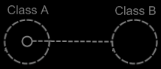

Because Class A has a sub-object of Class B, this creates a relation from Class A to Class B. However, Class B does not have a relation back to Class A yet. The picture below, adds the relation back to Class A:

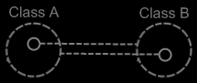

Because the class references back and forth are so closely related, the two class lines merge together to form the picture below:

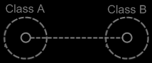

This, however, creates an ambiguity in the notation. The two circles tied together with a class line suggest, that they are both the same class. But the circle inside Class A represents Class B and the circle inside Class B represents Class A.

Fortunately, the notation can be disambiguated using the rules of automatic containment. Automatic containment is explained in the article Automatic Containment. Before explaining how automatic containment leads to the eventual notation, here is the disambiguated notation of a relation between two classes:

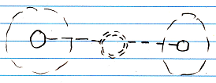

The notation is accomplished by first taking the original picture with one class refering to another and the other refering back to the first class:

Then, an imaginary reference to each class is added to the diagram

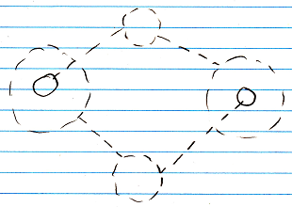

Next, the class lines are merged, but also the class symbols are merged:

The notation would still be ambiguous, if it weren’t for the double dashed line of the merged class symbols. So a double dashed circle symbolizes a relation between classes.

The picture above expresses a 1 → 1 relation between Class A and Class B. But other multiplicities can also be used. The multiplicity of n is expressed with a nonagon:



A nonagon represents a list of things. Instead of letting a Class A contain a single item of Class B, you can let is contain a list of items of Class B:

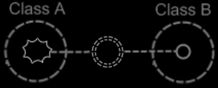

The picture above expresses an n → 1 relation between Class A and Class B.
The picture below displays a 1 → n relation between Class A and Class B.

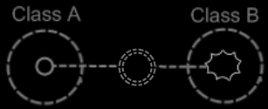

Finally, the picture below displays an n → n relation between Class A and Class B.

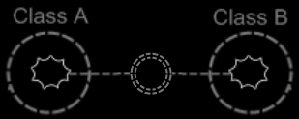

A symbol merge in a relation that has nonagons in it also results in a double dashed circle, because the imaginary reference to the classes, that are put on a higher level, are represented by circles, not a nonagons.

One related list can also contain items from multiple classes. Class A has a n → 1 relation to items of Class B and Class C, it is expressed as follows:

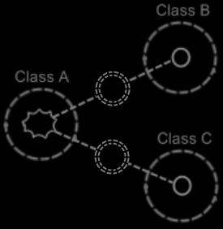

Class relating to itself
A class can have a relation to itself. For instance, a person can relate to a parent, which is also a person. So a person is related to a person, which relates a class to itself.

A class relating to itself looks as follows in a diagram:

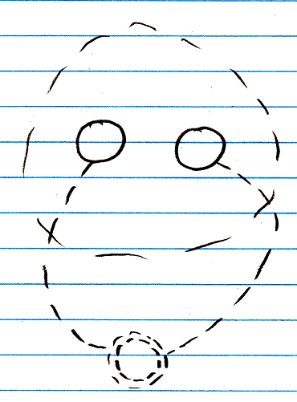

Counterpart out of sight
When the counterpart of the relation is out of sight, a line should point out of the diagram. A catch there is, that you can’t see if the relation counterpart is part of a multiplicity of n or not. Therefore, the multiplicity is expressed at the end of th line pointing out of the diagram as follows:

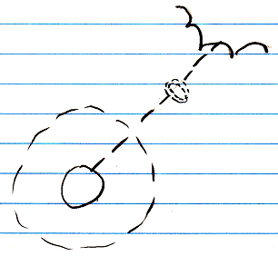

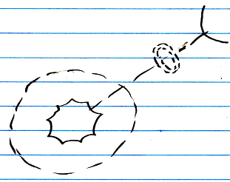

No reuse of merged imaginary references
If two imaginary references have merged, to become a relation symbol, then other references to the same classes won’t connect to an imaginary reference that has merged to become a relation symbol. Relations create their own imaginary references, that aren’t reused. This is displayed in the article Relations Between Objects in a Diagram, but may also apply to the notation of relations between classes.

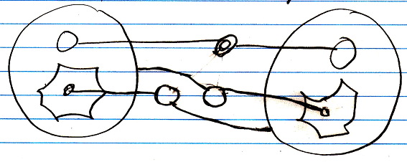

Example
Classes and their relations define the behavior of your system, so it is very important to be aware of them, instead of just looking at individual objects, tied to other objects.

The example below is part of the class-relation structure of a drawing program.
It displays the classes Application, Document, Point and Line.

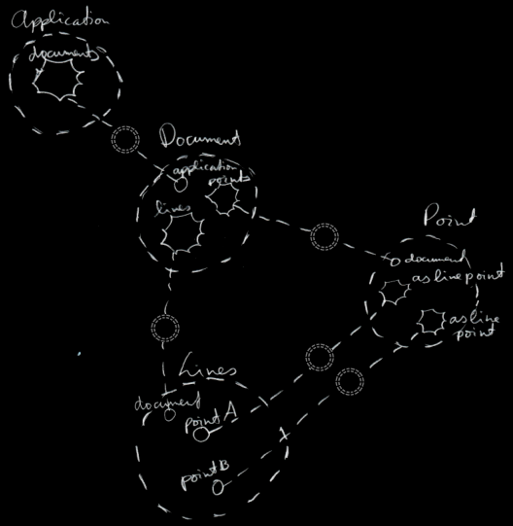

An instance of the application can hold multiple open documents. So Application has a 1 → n relation with Document. That automatically makes a document part of one instance of the application. A document holds a collection of points and a collection of lines. That makes Document have a 1 → n relation with Point and a 1 → n relation with Line. This automatically makes Points and Lines part of a single document. Furthermore, a line is composed of two points. However, if you chain lines together, a point can become a part of multiple lines. This gives Line two 1 → n relations with a Point: one for the first point and one for the second point.

The example displays all the classes, relations, related items and related lists of the object structure.

If just the use of dashed lines does not emphasize the classes and relations enough, a coloring could be applied to the diagram, highlighting all the classes and relations.

See also: Relations, Related Classes in a Diagram, Relations Between Objects in a Diagram

Author & Copyright: Jan-Joost van Zon Date: May 21, 2008 – June 19, 2008 Location: Oosterhout, The Netherlands Status: Finished

